PROJECT ON EMPLOYEE MANAGEMENT SYSTEM IN JAVA
CODE:
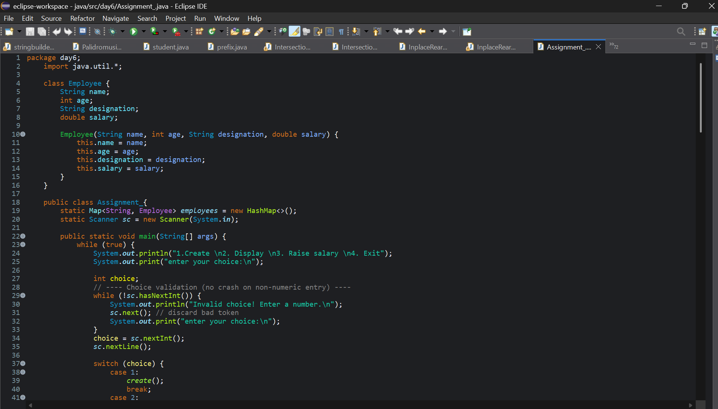
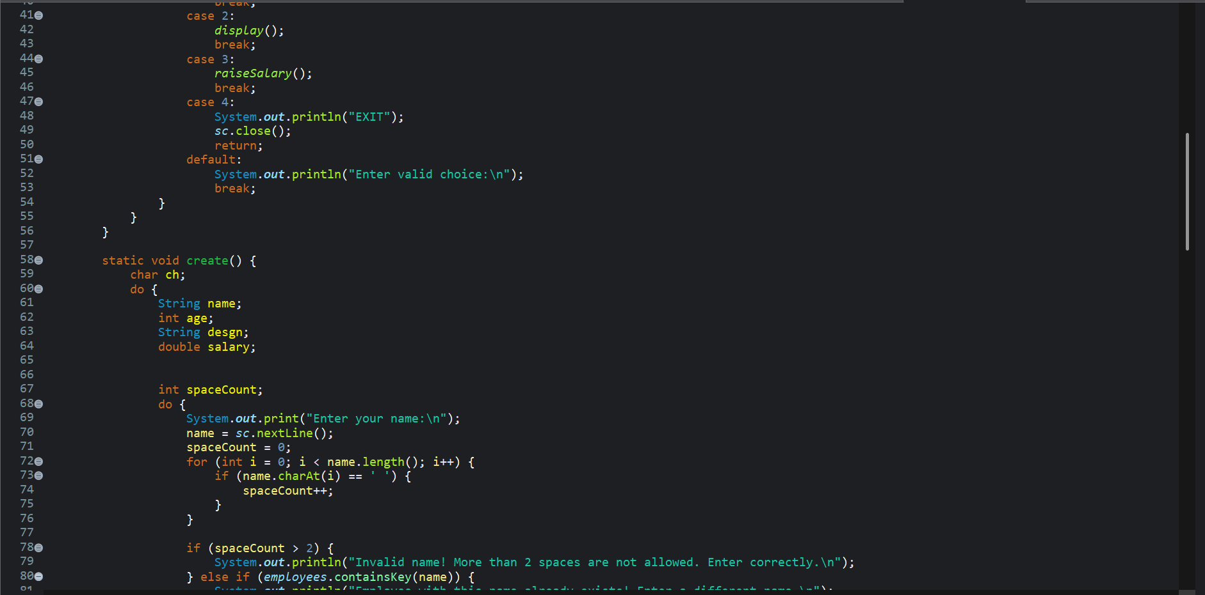
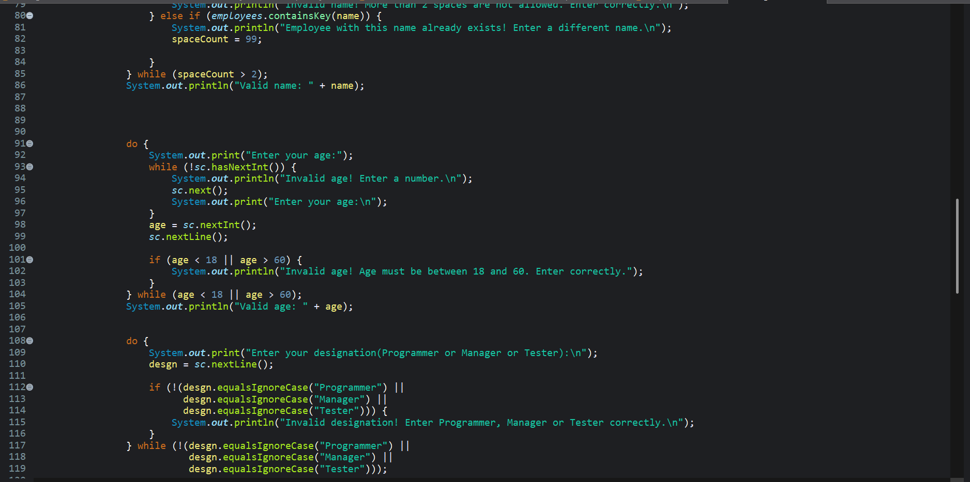
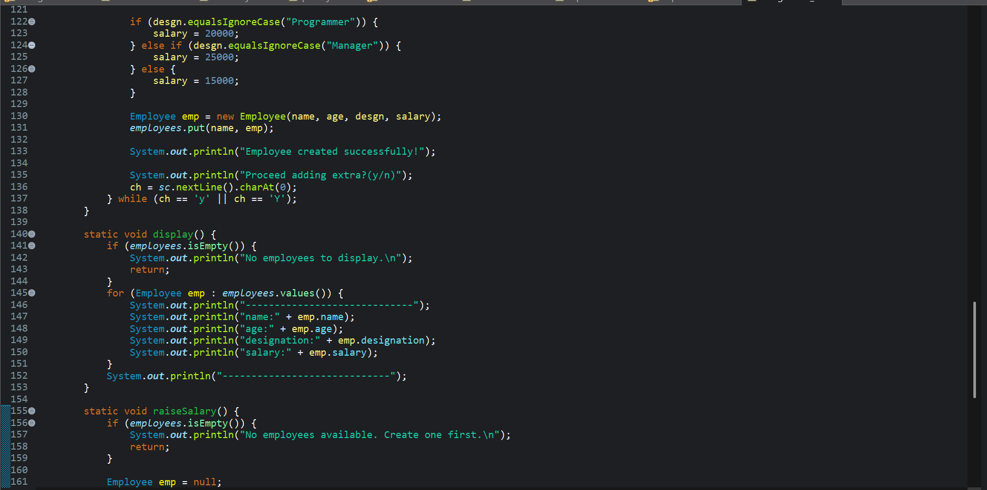
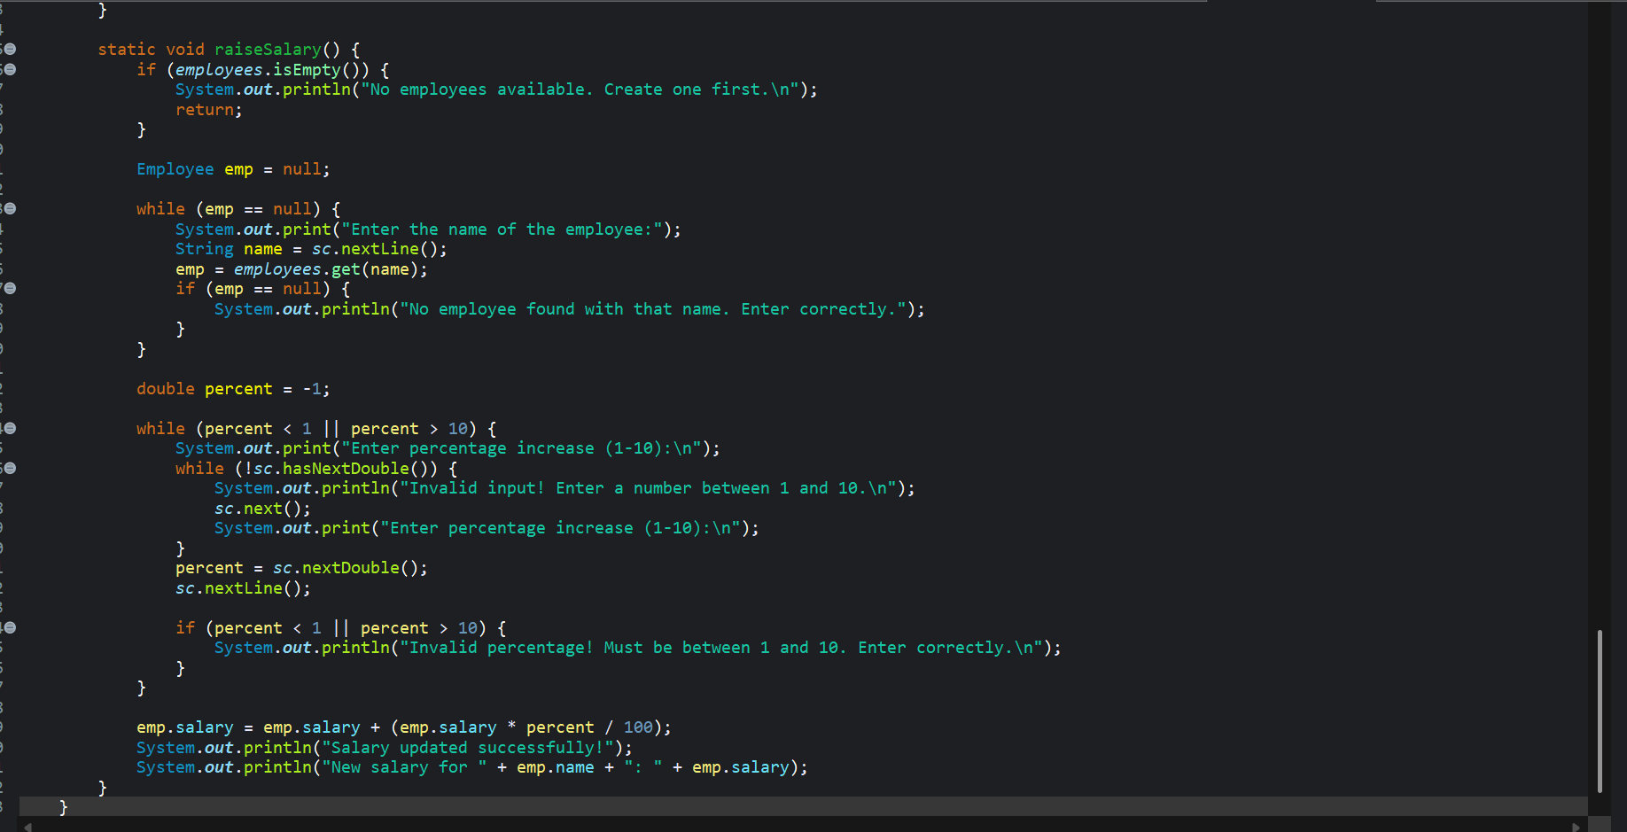
OUTPUT:
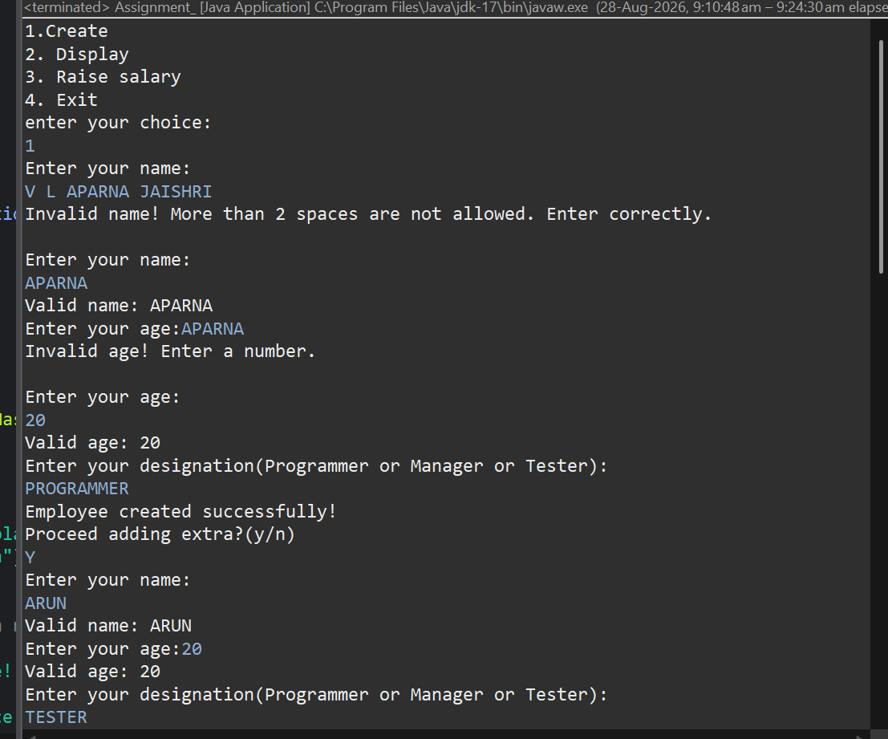
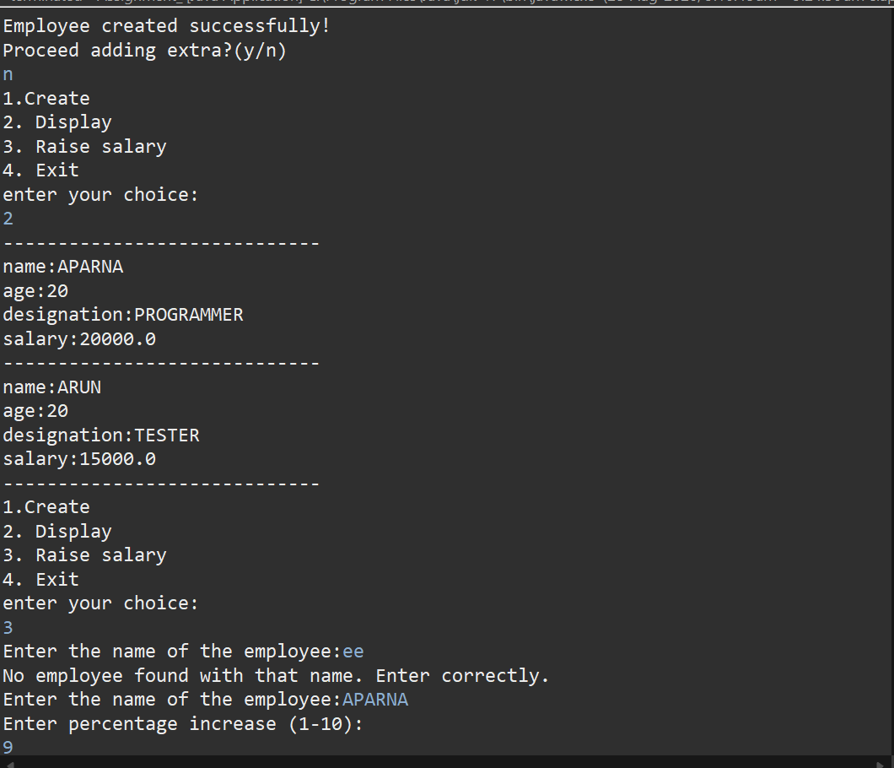
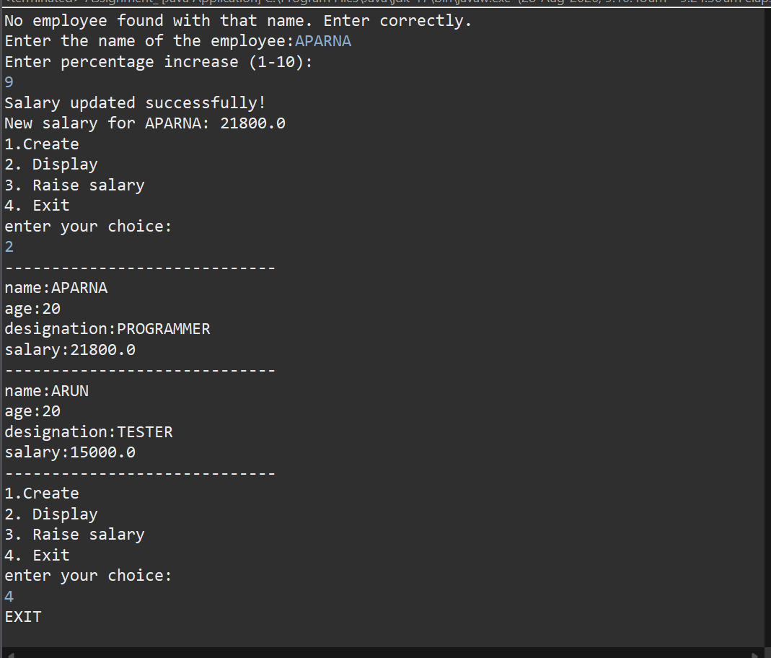

EXPLANATION
This Java program is an Employee Management System that uses a HashMap to store employee details. It provides four options: Create, Display, Raise Salary, and Exit. The program uses switch, loops, Scanner, input validation, and an Employee class to manage the employees.
Employee Class
The Employee class stores four details: name, age, designation, and salary. The constructor is used to initialize these values when a new employee is created.
Case 1 – Create
Case 1 calls the create() method. It asks the user to enter the employee's name, age, and designation. The name is checked so that it does not contain more than two spaces and the same employee name cannot be entered twice. The age must be between 18 and 60. The designation must be Programmer, Manager, or Tester. Based on the designation, the starting salary is automatically assigned: Programmer – ₹20,000, Manager – ₹25,000, and Tester – ₹15,000. Finally, the employee is stored in the HashMap. The user can also choose to add another employee.
Case 2 – Display
Case 2 calls the display() method. It first checks whether there are any employees in the HashMap. If there are no employees, it displays a message saying that there are no employees to display. Otherwise, it uses a for-each loop to go through all employees and displays their name, age, designation, and salary.
Case 3 – Raise Salary
Case 3 calls the raiseSalary() method. It first checks whether any employees exist. Then it asks the user to enter the name of the employee whose salary should be increased. The program searches for that employee in the HashMap. If the name is not found, it asks the user to enter the name again. After finding the employee, it asks for a salary increase between 1% and 10%. The new salary is calculated and updated. For example, if the salary is ₹20,000 and the increase is 10%, the new salary becomes ₹22,000.
Case 4 – Exit
Case 4 exits the program. It prints "EXIT", closes the Scanner, and uses return to stop the main() method.
Input Validation
The program also validates numeric inputs using hasNextInt() and hasNextDouble(). This prevents the program from crashing when the user enters invalid data such as letters instead of numbers. The while and do-while loops repeatedly ask for input until the user enters valid information.

